[CLAUDIA ALVES]
[GRAPHIC DESIGNER]
[@REALLYGREATSITE]

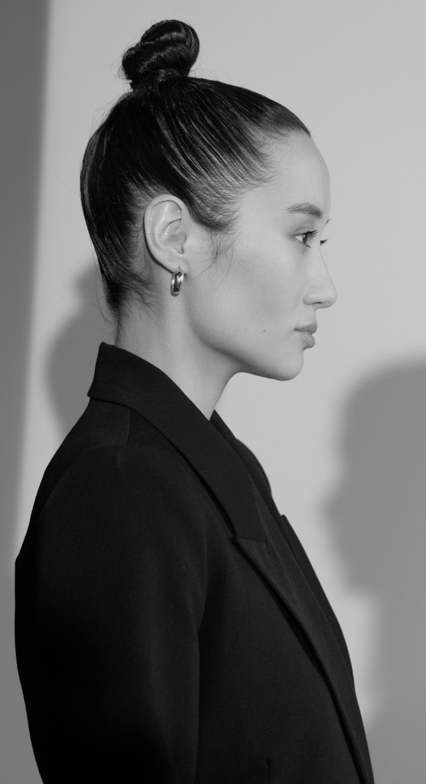
CLAUDIA ALVES

WORK EXPERIENCE SKILLS

LICERIA & CO.
2021-2024

STUDIO SHODWE
2019-2021

Job Position

Job Position
TYPOGRAPHY

PHOTOGRAPHY

VIDEO EDITING

LARANA, INC.
2017-2018

LANGUAGES

ENGLISH

SPANISH KOREAN

REFERENCE

OLIVIA WILSON
Job Position

LOREM IPSUM DOLOR SIT AMET, CONSECTETUR ADIPISCING ELIT. NULLAM PHARETRA IN LOREM AT LAOREET. DONEC HENDRERIT LIBERO EGET EST TEMPOR, QUIS TEMPUS ARCU ELEMENTUM. IN ELEMENTUM ELIT AT DUI TRISTIQUE FEUGIAT.

MOTION GRAPHIC

EDUCATION

REALLY GREAT UNIVERSITY
JUNE 2017-
JULY 2018
Enter Your Degree

REALLY GREAT UNIVERSITY

CEO | Studio Shodwe
hello@reallygreatsite.com

+123-456-7890
CsauPia Asxẹs
JUNE 2012-
JULY 2016
Enter Your Degree

@REALLYGREATSITE | PHONE | ADDRESS
[CLAUDIA ALVES] | [+123-456-7890] | [123 ANYWHERE ST., ANY CITY]

