[CLAUDIA ALVES]

[GRAPHIC DESIGNER]

[@REALLYGREATSITE]

CLAUDIA ALVES

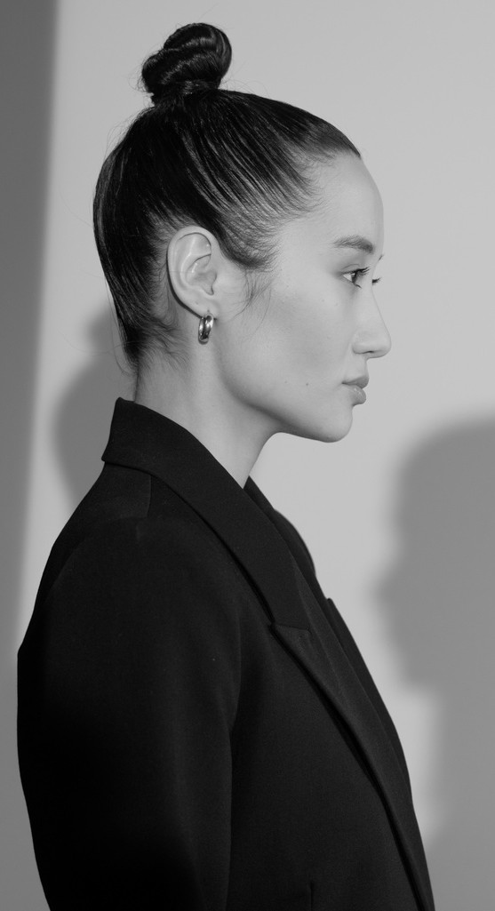

# WORK EXPERIENCE SKILLS

LICERIA & CO.

2021-2024

STUDIO SHODWE

2019-2021

*Job Position*

*Job Position*

TYPOGRAPHY

PHOTOGRAPHY

VIDEO EDITING

LARANA, INC.

2017-2018

# LANGUAGES

ENGLISH

SPANISH KOREAN

# REFERENCE

OLIVIA WILSON

*Job Position*

LOREM IPSUM DOLOR SIT AMET, CONSECTETUR ADIPISCING ELIT. NULLAM PHARETRA IN LOREM AT LAOREET. DONEC HENDRERIT LIBERO EGET EST TEMPOR, QUIS TEMPUS ARCU ELEMENTUM. IN ELEMENTUM ELIT AT DUI TRISTIQUE FEUGIAT.

MOTION GRAPHIC

# EDUCATION

REALLY GREAT UNIVERSITY

JUNE 2017-

JULY 2018

*Enter Your Degree*

REALLY GREAT UNIVERSITY

## CEO | Studio Shodwe

[hello@reallygreatsite.com](mailto:hello@reallygreatsite.com)

## +123-456-7890

CsauPia Asxẹs

JUNE 2012-

JULY 2016

*Enter Your Degree*

|  |  |  |
| --- | --- | --- |
| **@REALLYGREATSITE** | **PHONE** | **ADDRESS** |
| [CLAUDIA ALVES] | [+123-456-7890] | [123 ANYWHERE ST., ANY CITY] |